|  |  |
| --- | --- |
| Date | 18.10.2022 |
| Team ID | PNT2022TMID12337 |
| Project Name | SMART WASTE MANAGEMENT FOR METROPOLITIEN CITIES |
| Maximum Marks | 2 Marks |

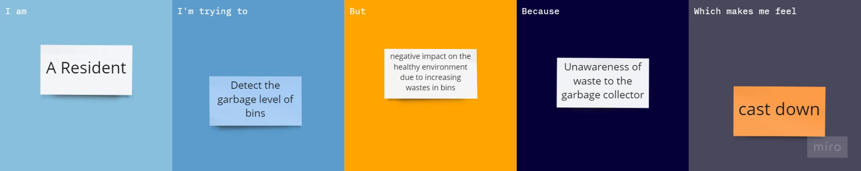

|  |  |  |  |  |  |
| --- | --- | --- | --- | --- | --- |
| **Problem Statement (PS)** | **I am (Customer)** | **I’m trying to** | **But** | **Because** | **Which makes me feel** |
| PS-1 | A Resident | Detect the garbage level of bins | negative impact on the healthy environment due to increasing wastes in bins | Unawareness of waste to the garbage collector | Cast down |
| PS-2 | Municipal Employee | Continuously monitoring the garbage level and location of the bins through Android app | Collected the wastes by municipality or private company truck at the predefined times | Brings out a bad smell and an unhygienic condition for the people living area | Obsessed |